**FEBRUARY, 2016**

**HARAMAYA UNIVERSITY, ETHIOPIA**

**SUBMITTED TO: HABTAMU.B**

**HARAMAYA UNIVERSITY**

**COLLEGE OF COMPUTING AND INFORMATICS**

**DEPARTMENT OF INFORMATION TECHNOLOGY**

**Distance and Continuing Education Management System for Haramaya University**

**PREPARED BY ID NUMBER**

1. **MEAZA ESHETU 1962/05**
2. **JALENE TESFAYE 1912/05**
3. **NESTANET 1112/04**

Table of Contents

I. Abstract VI

II. Acknowledgement VII

Chapter One 1

1. Introduction 1

➢ Software and hardware Requirement 1

1.1 Background of the organization 2

1.2 Statement of the problem 2

1.3 Objectives of the project 2

1.3.1 General objective 2

1.3.2 Specific Objectives 3

1.4 Project scope 1.4.1 In scope 3

1.5 significance of project 4

1.6 Methodology 4

1.6.1 Requirement Gathering Methods 4

1.6.2 Requirement Modeling 4

1.6.3 Development Environment and Programming Tools 5

1.7 FEASIBILTY STUDY 5

1.7.1 Technical Feasibility 6

1.7.2 Economic Feasibility 6

1.7.3 Time Feasibility 7

2 CHAPTER TWO: ANALYSIS 8

2.1 Existing System 8

2.1.1 Existing system Description 8

2.1.3 Business Rules 9

2.2 New System (proposed system) 11

2.2.1 Functional requirements 11

2.2.2 Non-functional requirements 13

**2.2.2.1 Workability** 13

**2.2.2.3 Usability** 13

**2.2.2.4 Efficiency** 13

**2.2.2.5 Maintainability** 13

**2.2.2.6 Portability** 13

**2.2.2.7 Correctness** 13

**2.2.2.8 Concurrency** 13

**2.2.2.9 Availability** 14

**2.2.2.10 User Interface** 14

**2.2.2.11 Security** 14

2.3 Use case diagram. 15

2.3.1 Use case documentation 16

2.4 Sequence diagram 38

2.5 State chart diagram 59

2.6 Activity diagram 64

2.7 Key abstraction with CRC analysis 82

2.8 Conceptual modeling: Class diagram 83

2.9 Identifying change cases 85

2.10 User Interface Prototyping 86

Chapter Three: Design 87

3.1 Purpose and goals of design 87

3.1.1 Objectives of design goals 87

3.1.2 Current software architecture 87

3.1.3 Proposed software architecture 88

3.2 Hardware/Software mapping 88

Software 88

Hardware 89

3.3 Subsystem decomposition 90

3.4 Class Collaboration Diagram 91

3.5 Layering class model 99

3.6 Component diagram 100

3.7 Deployment diagram 101

3.8 Persistence modeling for object oriented database 102

3.9 Access control and security 103

# Table of tables………………………………………………………………Pages

Table 1Gant chart or schedule feasibility 7

Table 2 Use case description for Login 16

Table 3 Use case description for Logout 17

Table 4 Use case description search or access student information 17

Table 5 Use case description for applying for registration request 18

Table 6 Use case description for Register online and register new students 19

Table 7 Use case description for Withdrawal request 21

Table 8 Use case description of View grade report and view status 22

Table 9 Use case description for view student status 23

Table 10 Use case description for access E-Learning 24

Table 11 Use case description for Paying online i.e. transaction 25

Table 12 Use case description for Handle student Requests 26

Table 13 Use case description of Make Id card for students 27

Table 14 Use case description for upload e-learning resources for students 28

Table 15 Use case description for send notification for students 29

Table 16 Use case description for Grade report 30

Table 17 Use case description for Manage user account 31

Table 18 Use case description for Update user account 32

Table 19 Use case description for Create user Account 33

Table 20 Use case description for Manage E-Learning resources 35

Table 21 Use case description for accessing student information 36

Table 22 Use case description for handling student online payment process i.e. transaction 37

**Table of Figures……………………………………………………………………………………Pages**

Figure 1 Use Case Diagram of distance and continuing education. 15

Figure 2 Sequence diagram of login 38

Figure 3 Sequence diagram of logout 39

Figure 4 Sequence diagram of access student information i.e. search student 40

Figure 5 Sequence diagram of Apply registration request 41

Figure 6 Sequence diagram of register online 42

Figure 7 Sequence diagram of view grade report 43

Figure 8 Sequence diagram of apply for registration request 44

Figure 9 Sequence diagram of withdrawal request 45

Figure 10 Sequence diagram of Accessing E-Learning 46

Figure 11 Sequence diagram of online payment i.e. Transaction 47

Figure 12 Sequence diagram of Handling request i.e. request approval 48

Figure 13 Sequence diagram of Upload e-learning resources for students i.e. E-Learning 49

Figure 14 Sequence diagram of sending notification for students 50

Figure 15 Sequence diagram of register new student 51

Figure 16 Sequence diagram of handling student payment and generating receipt paid students 52

Figure 17 Sequence diagram of make Id card 53

Figure 18 Sequence diagram of Generate grade report 54

Figure 19 Sequence diagram of submitting student grade report 55

Figure 20 Sequence diagram of Manage user account 56

Figure 21 Sequence diagram of create user account 57

Figure 22 Sequence diagram of updating account 58

Figure 23 Sequence diagram of update/change user account 59

Figure 24 State chart Diagram of student class 60

Figure 25 State chart diagram of Registrar class 61

Figure 26 State chart diagram of Administrator class 62

Figure 27 State chart diagram of Staff Class 63

Figure 28 State chart diagram of Finance class 64

Figure 29 Activity diagram of search or access student information 65

Figure 30 Activity Diagram of Register new student 66

Figure 31 Activity diagram of handling student request 67

Figure 32 Activity diagram of make student status 68

Figure 33 Activity diagram of make ID card for students 69

Figure 34 Activity diagram for upload e-learning resources for students 70

Figure 35 Activity diagram for send notifications for students 71

Figure 36 Activity diagram of register new student 72

Figure 37 Activity diagram of generate grade report for students 73

Figure 38 Activity diagram of generate receipt for students 75

Figure 39 Activity diagram of manage account 76

Figure 40 Activity diagram of Manage E-Learning 77

Figure 41 Activity diagram of pay online for the courses 78

Figure 42 Activity diagram of access E-Learning Resources 79

Figure 43 Activity diagram of viewing grade report and viewing status 80

Figure 44 Activity diagram of upload e-learning resources 81

Figure 45 Activity diagram of Submit student grade report 82

Figure 46 Activity diagram of send withdrawal request 83

Figure 47 Key abstraction with CRC analysis. 84

Figure 48 Class modeling diagram. 86

Figure 49 User Interface design or user interface prototype 88

Figure 50 Sub system decomposition 92

Figure 51Class Collaboration diagram of registering new student. 93

Figure 52 Class Collaboration diagram of creating new user account. 94

Figure 53 Class Collaboration diagram of handling student’s request. 95

Figure 54 Class collaboration diagram of sending notification for students 96

Figure 55 Class collaboration diagram of submitting students’ grade report 97

Figure 56 Class collaboration diagram of online payment 98

Figure 57 Class collaboration diagram of sending withdrawal request 99

Figure 58 Class collaboration diagram of generating receipt for students 100

Figure 59 Layering class model 101

Figure 60 Component diagram 102

Figure 61 Deployment diagram of distance and continuing education 103

Figure 62 persistence modeling diagram 104

# I. Abstract

Haramaya University distance and continuing education program is still using manual system to perform all activities in the University. So, we proposed to make the website for college of distance and continuing education to make the operation process to be web based to increase, improve and simplify all activities related to students. For this reason we analyzed the existing manual system of the school and identified the existing system problems, which are the base to develop the proposed system. To propose the system, we gathered requirements as much as needed and specified the significance of the proposed system. Depending on the significance, we identified the functional requirements of the proposed system and designed the use case diagram of the college of distance and continuing education management system. We documented all the use cases and the corresponding actors of each use cases. In the design phase of the proposed system, we designed the sequence diagrams, activity diagrams, state chart diagrams, class diagrams, collaboration diagrams, and class layering diagrams, class responsibility collaborations user interface diagrams, decomposition diagrams, component diagrams, deployment diagrams and persistence modeling of the proposed system by using the object oriented design architecture.

Finally, we identified the proposed system software architecture, the design goals of the system, and the access control and security mechanism of the proposed system.

# II. Acknowledgement

First of all we would like to express our internal and endless thanks to Almighty **God** who helped in every aspects of our life and made us to being graduating student in this academic year. Next we would like to express our deepest gratitude to coordinators of distance and continuing education program of the University, who supported us honestly and kindly by giving all the information and operation techniques of the program and forms that the manual system is using for its operation during the requirement gathering phases of our system. Moreover we would like to express our heart gratitude to Mr. Habtamu Birru (our advisor), for his continues advice and to be with us in all ups and downs of our system documentation phase. We do not want to pass without expressing our gratitude to all staff members for honestly advising us in order to successfully develop our system during the time of proposal presentation. Last but not the least we would like to give our best gratitude from bottom of our heart to Mr. Habtamu Birru, the head of department Information Technology and our advisor for being with us.

# Chapter One

# 1. Introduction

This SRS Document is prepared for Continuing education program under the college of continuing and distance education of Haramaya University to develop computerized distance education management system for CEP. As the time goes by and technology evolves quickly, people manage to create an easier life in every aspect by manipulating the rapid growth of technology. Due to this reason existing manual system must be automated. The basic aim of this project is to solve the current problem of continuing and distance education of the University. The Currently working system is not suitable. They maintained series student data and record information, it is time consuming and difficult task to maintain a system process data manually. Considering this problem of the organization our development team has proposed to develop new system that has great significance for work efficiency of the College. During the time of automating system there are essentials requirement that are gathered from clients and end user of the project. The SRS document describes the basic requirements in the project. The basic purpose of this SRS is used to collect the entire necessary requirement and translate them to written document. Through this process the end user is describing what is expected from the software and the development team also understood what the real need of the customer, what is the necessary knowledge available to develop the system.

This documentation includes the following topics with their detailed information which are essential for the development of the system in our project.

* Specific requirements
* Software and hardware Requirement
* Functional requirements
* Non-functional requirement
* Software Design
* System decomposition
* User interface design

## ****1.1 Background of the organization****

## Haramaya University Continuing education program CEP under the College of continuing and distance education (CCDE) was established 30 years ago. It started with Certificate and Diploma Programs in the fields of agriculture delivering education at Haramaya University and Harar center. After few years, a new CEP center was established at Dire Dawa and Somali regional state at Jigjiga.The department gives education service for the students at these sectors. First the students apply to register by coming personally to one of the specified sectors. Then the department has its own criteria to approve the student’s application. The center employee/supervisor checks the registration form filled by the student weather it satisfies the criteria or not. If the student satisfies these criteria’s he/she will be approved to be registered. Then after the approval, the student will pay the payment for the courses that he/she will take. Then the student will be registered and start the class by the schedule posted by the department. The department handles this information manually. And the file management system is paper based. So, the information recording or filling and retrieval system is too tedious, error prone, and also time taking.

## 1.2 Statement of the problem

During requirement gathering we have notice that the college has done everything manually. They also manage student information and distance education programs manually. It is highly error prone and tedious work for the employees to handle the data recording process manually. And it’s also time consuming. Sometimes there is also a situation that the student information and distance education program courses may be lost. Rather than the above problems the following listed problem are some limitations:-

* The main problem of the current system is that all operations are performed manually including student information and the distance courses offered for them.
* Bulky works and time consuming processes
* The existence of data loss and miss management of student information and the course structures.

## 1.3 Objectives of the project

### 1.3.1 General objective

The general objective of the project is to automate the all processes taking place in the college of continuing and distance education program for the college including student information management system.

### 1.3.2 Specific Objectives

* To overcome the problem of manual student registration system
* Provide automated student information management system of distance and continuing education for the college.
* Enables fast data retrieval from the database related to distance education program.
* To make student and course information's available to the department at their desk whenever they need to see and offer their tasks.
* To have a centralized control over the distance education and grading system including the courses.
* To allow all relevant information about an individual to be retrieved readily to meet the college needs to facilitate the individuals' rights of access to their own personal information.

## 1.4 Project scope 1.4.1 in scope

This project will be limited on developing a web based Distance and continuing Education Program management system for Haramaya University. On the completion of this project the system is expected to provide:-

* Accurate way of recording and storing student information into the database who are attending the distance and continuing education program of the University.
* Accurate way of online access of the courses that the college offers for the students.
* Centralized user friendly and well organized student records and all the course matters.
* Provide new update information for students and continuing education program
* Online user registration and its approval including online payment for the courses
* Preparing grade report for students and making them to view their grade and their semester status after a certain semester.
* Online E-learning access and providing receipt for student who completed their payment and allowed to register.
* Allowing students to send requests to registrar and seeing notifications sent by the registrar

## 1.5 significance of project

This system is expected to overcome the problem stated in the statement of the problem and fulfill listed tasks determined in the scope of the system. The problem is that every activities of the CEP are carried out manually; manually done works are highly error prone, time taking, tedious, requires more employee and data loose. So our system solves these problems of the department by automating distance and continuing education activities which related to student registration and course related activities including E-learning access. This system is fully functioning web based system which is capable of providing the following major functionalities.

* Student registration and approval based on eligibility
* Registration and handling payment process of students
* Generating grade report for students and Managing E-learning
* Manage user accounts and uploading courses for students etc.

## 1.6 Methodology

### 1.6.1 Requirement Gathering Methods

Different method of data collection is used to gather information from both primary and secondary source. These are:-

1. Interview: - in this point we ask to the administrator office of continuing education program.
2. Document Analysis: - To get more information about our project we have used documents that help us to develop our project. During the analysis of documents, we give a special consideration to those documents which can bring more features to our system.

### 1.6.2 Requirement Modeling

Basically this project would follow the method of object oriented programming approach. Object-oriented programming offers a new and powerful model for writing computer software. Objects are "black boxes" which send and receive messages. This approach speeds the development of new programs, and, if properly used, improves the maintenance, reusability.

### 1.6.3 Development Environment and Programming Tools

Developing this project the team selects the following environment and programming tools

* Microsoft office 2010 used for the documentation part of this project.
* Concerning the development of the database we will use MySQL server integrated in XAMPP server.
* Edraw Max 7.9 software and Visual Paradigm for UML 10.2 for modeling and drawing use case diagram, sequence diagram, class diagram, deployment model and ERD
* Concerning coding we are going to use Notepad++.

## 1.7 FEASIBILTY STUDY

A feasibility analysis usually involves a thorough assessment of the operational (need), financial and technical aspects of a proposal. Feasibility study is the test of the system proposal made to identify whether the user needs may be satisfied using the current software and hardware technologies, whether the system will be cost effective from a business point of view and whether it can be developed with the given budgetary constraints. A feasibility study should be relatively cheap and done at the earliest possible time. Depending on the study, the decision is made whether to go ahead with a more detailed analysis.

When a new project is proposed, it normally goes through feasibility assessment. Feasibility study is carried out to determine whether the proposed system is possible to develop with available resources and what should be the cost consideration. Facts considered in the feasibility analysis were.

* Technical Feasibility
* Economic Feasibility
* Time Feasibility

### 1.7.1 Technical Feasibility

Technical Feasibility deals with the hardware as well as software requirements. Technology is not a constraint to type system development. We have to find out whether the necessary technology, the proposed equipment’s have the capacity to hold the data, which is used in the project, should be checked to carry out this technical feasibility.

The technical feasibility issues usually raised during the feasibility stage of investigation includes these

* The system is platform independent i.e. can run in any operating system the only thing needed is internet connection.
* The system can be expanded.

### 1.7.2 Economic Feasibility

This feasibility study present tangible and intangible benefits from the prefect by comparing the development and operational cost. The technique of cost benefit analysis is often used as a basis for assessing economic feasibility. This system needs some more initial investment than the existing system, but it can be justifiable that it will improve quality of service.

Thus feasibility study should center along the following points:

Tangible benefits

* Reduction of paper and pen.
* Reduction of space needed to process all activities taking place in distance and continuing education program of the college.

Intangible benefit:

* Improve employees works
* Give better and effective service
* Error reduction
* Increase security
* Increase speed

### 1.7.3 Time Feasibility

The schedule for this project will be feasible due to proper information exchange between the developing team and the Advisor. And also the time set to develop the application is enough to complete at the predefined day and time since the project is supposed to be completed in 8 months i.e. 4 months for documentation and the rest 4 months for implementation and testing.



Table 1Gant chart or schedule feasibility

# 2 CHAPTER TWO: ANALYSIS

## 2.1 Existing System

### 2.1.1 Existing system Description

## Haramaya University CEP under the College of continuing and distance education (CCDE) was established 30 years ago. It started with Certificate and Diploma Programs in the fields of agriculture delivering education at Haramaya University and Harar centre. After few years, a new CEP center was established at Dire Dawa and Somali regional state at Jigjiga. The college gives education for the students at these sectors. First the students apply to register by coming personally to one of the specified sectors. Then the college has its own criteria to approve the student’s application. The center coordinator checks the registration form filled by the student weather it satisfies the criteria or not. If the student satisfies these criteria’s he/she will be approved to be registered. Then after the approval, the student will pay the payment for the courses that he/she will take. Then the student will be registered and start the class by the schedule posted by the department. The college handles student information and course that the students attent manually. So, the information recording or management system is too tedious, error prone, and also it takes long time.

## The drawbacks of existing system are that the college manages its activities in paper manually. Because of this we had found the problems described below.

* There is a searching problem. Since there are so many student information are found in the record room, searching for student information and his course information is time consuming for the record employee. So that, quickly identifying student information is very difficult. This leads to elongation of the overall working processes.

### There is control and security problem and because of this problem, unauthorized workers are capable to access student and course information.

* The use of several forms and copies in the record keeping will incur additional material cost.
* Very tedious and time consuming advertisement and promotion about the college programs, and registration date.
* Students are wasting time and money by traveling back and forth for application and registration process since application and registration time is different.
* It is tedious to manage historical data of students and their course information which needs much space to keep all the information regarding the students.
* Since this information are stored on a cabinet (shelf) data's are prone for damage and loose.
* Tasks are vulnerable for mistakes because they are performed by human beings. As a result works done may not accurate.
* Taking the above problems into consideration, we proposed to solve the problems of distance and continuing education for the college including the registration process since the problems are related to student information and managing E-learning.

### 2.1.3 Business Rules

#### 2.1.3.1 Business rule of the existing system

This describes the working rules being followed by the College of distance and continuing education program in the existing system which is performed manually.

**Application and admission rules**

Without any prejudice to directives given by the ministry of Education, eligible applicants to the continuing program of HU fall into the following categories.

1. **For Students whom attend the Degree program**

* To join CEP, must applicants have ESLCE result should be greater than or equals to with that ratified by ministry of education.

1. **Upgrading applicants**.

* Applicants with diploma (12+2 or 10+3) and cumulative grade point average (CGPA) of 2.00 up on graduation from an accredited higher learning institution of similar program are encouraged to apply.
* Technical and vocational education and training graduates with pertinent qualifications and who satisfy entrance qualification assessment set by the ministry of education can be admitted.
* Center of Competence (COC) is mandatory for all applicants having a diploma.
* All applicants must apply within the time period of the application days set by the office of the CEP.
* The application process is facilitated by the center coordinators until to the screening process is accomplished and list of accepted applicants are posted.
* All applicants should sign an agreement to pay tuition and related fees to the University.

1. **Illegal Admission**

* Securing or intending to secure admission using forged academic documents and examination results is illegal.
* Securing admission by posing oneself as a student to the University system after withdrawal, dropping out or dismissal is illegal.

1. **Registration rules**

* Students should pay their payment to the University in the bank and bring the receipt of the payment when they come for registration.
* Registration process should be accomplished with in the period set by the office of the CEP or according to the calendar of the university.
* In the failure to complete registration within the specified period of time results in registration with penalty. The penalty increases from day to day until penalty period is ended.
* A student, who did not accomplish the registration within the six days mentioned above, is only recommended to withdraw the program.
* The center coordinators shall immediately submit the registration slip with the lists of students identified by their respective departments to the secretary of CEP; after listing down the students who registered for the semester; the secretary of CEP submits to the database worker of the continuing education program.
* The database shall enter the registration slip into the database within five days.
* The database worker shall submit the registration slip to the record officer of the CEP.

## 2.2 New System (proposed system)

The proposed system mainly focuses on solving the problem of managing student information, student registration; managing e-learning and managing access to courses which was carried out manually, by developing a web based application for CEP. This system enables the college to manage distance and continuing education program easily and make the system to be accessed easily. The system also performs related works like applying for registration, registration and different user account management and e-learning management in automated way. It solves all problems that are listed in existed systems according to the business rules of CEP.

### 2.2.1 Functional requirements

The functional requirements of the system we are going to develop are as follows.

1. **Logging in to the system**

This is the first step for all of the actors that are taking place in the system in order to perform all of their business activities related to continuing and distance education.

1. **Logging out from the system**

After performing all of their tasks, each of the actors in this system are logging out from the system in order to protect unauthorized access of the system by any of the users.

1. **Searching Student information**

This in searching students by their id number to apply any of required processes up on them for example updating and deleting a certain student.

**I. From the student’s perspective**

1. student can request for registration
2. sending his/her withdrawal request at the time of different difficulty by logged in to his/her own account
3. View status i.e. Great distinction, distinction and etc.
4. Viewing and getting his/her grade report form
5. Access E-learning resources that is learning online the courses they registered to attend via E-learning
6. Access Notifications
7. Paying online payment for the University in the form of transaction

**II. from the Registrar Perspective**

1. Handling different requests sent from students i.e. approval and rejection
2. Making and giving student ID card
3. Make student status
4. Sending notifications for students about their requests
5. Generate or give grade report for students after the end of certain academic year

**III. from the Finance Perspective**

1. handling student payment process and generating or giving them the receipt of their payment

**IV. from the Administrator Perspective**

1. Manage user accounts i.e. creating, updating and deleting user accounts of both students and staffs
2. Manage E-learning resources
3. Access student Information

**V. From the Staffs Perspective**

1. Submit student grade
2. View student status
3. Upload E-learning resources
4. Notification resources

### 2.2.2 Non-functional requirements

**2.2.2.1 Workability**

The system should be Suitable for the all stakeholder of CEP. It should be accurate in performing its functions and secured enough from attacks by external users. It should be fully functional in terms of providing all the functions expected it to perform.

**2.2.2.2 Reliability**

The system should be reliable and matured enough in giving its service. It should have a fault tolerance mechanism in which it can recover fast from problems that may occur.

**2.2.2.3 Usability**

The system should be understandable by all users. The interface should be easy to use and it should have a customary look and feel so that users can easily be familiar with the system. It should be easy to learn and operate. It should be usable for accomplishing tasks to the client.

**2.2.2.4 Efficiency**

The system should be efficient and the response time should be minimal. It should be capable of running on minimum hardware requirements and with the familiar operating systems.

**2.2.2.5 Maintainability**

The System should be easily maintainable in case of problems and gives consistent service at all times without fluctuation until there is internet connection and should be testable.

**2.2.2.6 Portability**

The system should be portable in running on different platforms.

**2.2.2.7 Correctness**

The system provides correct response to the correct request.

**2.2.2.8 Concurrency**

The system should support multiple accesses of users. It should give service to multiple users concurrently.

**2.2.2.9 Availability**

The system is available for the user whenever there is an internet connection.

**2.2.2.10 User Interface**

The interface of the system should be user friendly, that is, it should be understandable, usable and corrective.

**2.2.2.11 Security**

The system should be secured from external attackers and internal misuse. It should have a user’s database and should authenticate each user on log in and should grant user specific services. The confidentiality of the information gathered during requirement analysis and later phases are kept private and used only for the development of the system internally. This helps to prevent external parties and unauthorized groups from getting to know and attacking the system.

## 2.3 Use case diagram.

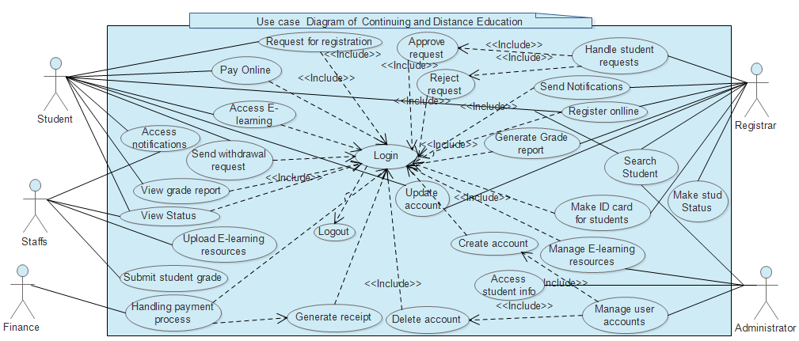

Figure 1 Use Case Diagram of distance and continuing education.

### 2.3.1 Use case documentation

Table 2 Use case description for Login

|  |  |
| --- | --- |
| **Use Case Id:** | SUC-1 |
| **Use Case Name:** | Login |
| **Use Case Description** | This use case describes how a user logs into the CEP System. |
| **Actors:** | * Student * Registrar * Finance * Staffs * Administrator |
| **Preconditions:** | * Actors must have account. |
| **Triggers:** | When the actor wishes to log into the CEP System. |
| **Normal Flow:** | 1. The actor click login menu bar 2. The system display login form 3. The user enter user id and password 4. The system validates the entered information. 5. The system display user page. 6. User logged in to his/her own page 7. use case end |
| **Post condition:** | If the use case was successful, the actor is now logged into the system. If not, the system state is unchanged. |
| **Alternate Flow:** | A4. Entered User Id or password is Invalid   1. The system informed the user an error message 2. go to step 3 3. end use case |

Table 3 Use case description for Logout

|  |  |
| --- | --- |
| **Use Case Id:** | SUC-2 |
| **Use Case Name:** | Logout |
| **Use Case Description** | This use case describes how a user logs out from CEP System. |
| **Actors:** | * Student * Registrar * Finance * Staffs * Administrator |
| **Preconditions:** | * Actors must have account. |
| **Triggers:** | When the actor wishes to log out from the CEP System. |
| **Normal Flow:** | 1. The actor click logout menu bar 2. The system display logout from the system 3. The system display users login page. 4. use case end |
| **Post condition:** | If the use case was successful, the actor is now logged out from the system. If not, the system state is unchanged the means the user is still in his/her home page. |
| **Alternate Flow:** |  |

Table 4 Use case description search or access student information

|  |  |
| --- | --- |
| **Use Case Id:** | SUC-3 |
| **Use Case Name:** | Search student i.e. access student information |
| **Use Case Description** | This use case describes how a certain student searches his/her own information or other users search the students information |
| **Actors:** | 1. Student 2. Registrar 3. Administrator |
| **Preconditions:** | * Actors must have account. |
| **Triggers:** | When the actor wishes to search student information for the CEP System. |
| **Normal Flow:** | 1. The actor should login into the system 2. The system display user home page. 3. User clicks on search menu 4. The system displays the form that asks student id. 5. The user fills the form 6. The system validates the form 7. The user clicks on search button 8. The system displays student information 9. use case end |
| **Post condition:** | If the use case was successful, the actor is finds student information. If not, the user cannot see student information. |
| **Alternate Flow:** | A4. Invalid student Id number   1. The system informed the user an error message 2. go to step 5 3. Use case continues with normal flow. |

Table 5 Use case description for applying for registration request

|  |  |
| --- | --- |
| **Use Case ID:** | SUC-04 |
| **Use Case Name:** | Apply for registration request |
| **Actors:** | Student |
| **Description:** | This system process, enable the new student to apply for registration by filling all the necessary information. |
| **Trigger:** | When the student wants to apply for registration |
| **Preconditions:** | The student should be new student |
| **Normal Flow:** | 1. The user selects “Request for registration” option 2. The System displays application form 3. The user enters all the necessary data on to the form. 4. The user click Submit button 5. System replay success message 6. Use case end |
| **Post conditions:** | The new student apply for registration |
| **Alternative Flows:** | A3. If all the data is not filled   1. System display an error message 2. Return to step 2 3. Use case end |

Table 6 Use case description for Register online and register new students

|  |  |
| --- | --- |
| **Use Case ID:** | SUC-05 |
| **Use Case Name:** | Register students online |
| **Actors:** | Student  Registrar |
| **Description:** | This system process helps to register approved and paid applicants, senior students and readmission students with withdrawal case or dismissal with readmission. |
| **Trigger:** | When the approved student wants to registration |
| **Preconditions:** | The student should be approved to be registered. |
| **Normal Flow:** | 1. The user logs in to the system 2. The system displays users page 3. The user selects “New student registration” option. 4. The System displays a list of paid students. 5. The user enters full name and click "Register" button in the same page. 6. System automatically gives Id number and passcode to student. 7. A system registers student data. 8. System display to the user student information, passcode and id number in email form. 9. The user enters displayed information in email form and click send email button from the same page. 10. System send email to the student 11. use case end |
| **Post conditions:** | The student will be registered |
| **Alternative Flows:** | A1. If the student is senior   1. the user select “Senior student registration” option 2. system prompt the user to enter academic year and department 3. user fill the data and click on ok button 4. system display list of the students 5. The user check payment status of the student 6. The user inserts the student ID and click on “update” option. 7. The system updates the students status 8. Use case end   A1.1 if the student is readmission with withdrawal or dismissal with readmission   1. User select “readmission” option 2. System display list of students with readmission status 3. User check student payment status and click on register button 4. System register the student 5. Use case end |

Table 7 Use case description for Withdrawal request

|  |  |
| --- | --- |
| Use Case ID: | SUC-6 |
| Use Case Name: | Withdrawal request |
| Actors: | Student |
| Description: | This system process, enable the student to request for withdrawal in the time of different difficulties by mentioning the reason along with the request. |
| Trigger: | When the student want to withdraw. |
| Preconditions: |  |
| Normal Flow: | 1. Student logins in to the system 2. The system displays students home page 3. Student select “withdrawal request” option 4. System display the form to be filled 5. User fill the form and click submit button 6. System checks all the fields are filled 7. System save the request 8. System replay success message 9. Use case end |
| Post conditions: | Student sends withdrawal request |
| Alternative Flows: | A4. If the form is not filled completely   1. System display error message 2. Use case return to step 3 3. Use case end |

Table 8 Use case description of View grade report and view status

|  |  |
| --- | --- |
| Use Case ID: | SUC-7 |
| Use Case Name: | View grade report and view status |
| Actors: | Student |
| Description: | This system process, enable the student to view grade report after the end of one semester and during registration time of the next semester |
| Trigger: | When the student want to view grade report. |
| Preconditions: | Student should finish one semester |
| Normal Flow: | * + - 1. Student logins in to the system       2. The system displays students home page       3. Student clicks on view grade report button       4. System display the form that asks students id number and the semester courses and the year       5. User fill the form and click submit button       6. System checks all the fields are filled       7. System does grade report       8. System displays grade report for student  1. Student prints grade report 2. Use case end |
| Post conditions: | Student views and accepts grade report |
| Alternative Flows: | A4. If the form is not filled completely   1. System display error message 2. Use case return to step 5 3. Use case end |

Table 9 Use case description for view student status

|  |  |
| --- | --- |
| Use Case ID: | SUC-8 |
| Use Case Name: | View student status |
| Actors: | Student  Staff |
| Description: | This system process, enable the student and the staffs to view grade report after the end of one semester and during registration time of the next semester |
| Trigger: | When the student and Staffs want to view grade report. |
| Preconditions: | Student should finish one semester |
| Normal Flow: | * + - 1. The users login in to the system       2. The system displays users home page       3. Users clicks on view grade report button       4. System display the form that asks students id number and the semester they want to see       5. User fill the form and click view status button       6. System checks all the fields are filled       7. System displays status for needed student  1. Use case end |
| Post conditions: | Student and Staffs viewed status |
| Alternative Flows: | A4. If the form is not filled completely   1. System display error message 2. Use case return to step 5 3. Use case end |

Table 10 Use case description for access E-Learning

|  |  |
| --- | --- |
| Use Case ID: | SUC-9 |
| Use Case Name: | Access E-Learning resources |
| Actors: | Student |
| Description: | This system process, enable the student to access e-learning resources that the Staffs or instructors upload for him/her |
| Trigger: | When the student want to access e-learning resources. |
| Preconditions: | The e-learning resources should be uploaded |
| Normal Flow: | * + - 1. Student logins in to the system       2. The system displays students home page       3. Student clicks on view resources button       4. System display the displays the resources that are uploaded by instructor       5. Student selects the resources that he/she needs to access       6. System opens the resource that student needed       7. Student accesses/reads the resource       8. Use case end |
| Post conditions: | Student accessed online resources |
| Alternative Flows: | A4. If the resources are not uploaded   1. System display error message 2. Use case return to step 5 3. Use case end |

Table 11 Use case description for Paying online i.e. transaction

|  |  |
| --- | --- |
| Use Case ID: | SUC-10 |
| Use Case Name: | Pay online i.e. transaction |
| Actors: | Student |
| Description: | This system process, enable the student to pay online for the courses that he/she is going to attend in a certain semester |
| Trigger: | When the student want to pay online. |
| Preconditions: | Student should have bank account with enough balance |
| Normal Flow: | Student logins in to the system  The system displays students home page  Student clicks on online payment button  System displays the form that asks student to fill student account number, amount of payment and schools account number.  Student fills the form  System validates the form  Student submits the form  The systems performs transaction based on form information  The system displays success message  Use case end |
| Post conditions: | Student learned online |
| Alternative Flows: | A4. If the courses are not uploaded   1. System display error message 2. Use case return to step 5 3. Use case end |

Table 12 Use case description for Handle student Requests

|  |  |
| --- | --- |
| Use Case ID: | SUC-10. |
| Use Case Name: | Handle student requests and registration |
| Actors: | Registrar |
| Description: | This system process, enable the registrar staff to handle student request for withdrawal or registration when needed. |
| Trigger: |  |
| Preconditions: | Any of requests should be sent from the student |
| Normal Flow: | 1. Registrar staff should be login to the system 2. The system displays the users page 3. The user clicks on manage requests 4. System display lists of student requests 5. User clicks on the request that he wants to approve or reject 6. System display student request details 7. User check the student request and he either approve or reject the request 8. The user clicks on notify student button 9. The system sends notification for student in the form of email. 10. Use case end |
| Post conditions: | Student request will be handled i.e. either approved or rejected |
| Alternative Flows: |  |

Table 13 Use case description of make ID card for students

|  |  |
| --- | --- |
| **Use Case ID:** | SUC-11 |
| **Use Case Name:** | Make ID card for students |
| **Actors:** | Registrar |
| **Description:** | This system process used to make student ID card. |
| **Trigger:** | When the student wants his/her Id card. |
| **Preconditions:** | The student must be registered. |
| **Normal Flow:** | 1. The user should login to the system 2. The system displays the users page 3. The registrar staff select “Make ID Card” option 4. The system display all the registered students in that year 5. The user enter student ID and click on Make ID button 6. The system display student ID card 7. The user click on print button 8. The system prints student ID card 9. Use case end |
| **Post conditions:** | Student gets his/her ID card. |
| **Alternative Flows:** | A3. If user enters wrong student ID number   1. System display error message 2. Use case return to step 4 3. Use case end |

Table 14 Use case description for upload e-learning resources for students

|  |  |
| --- | --- |
| Use Case ID: | SUC-12 |
| Use Case Name: | Upload E-Learning resources for students |
| Actors: | Staffs |
| Description: | This system process, enable the staffs to upload e-learning resources for students |
| Trigger: | When the student wants to access e-learning resources. |
| Preconditions: | Student should pay and register |
| Normal Flow: | 1. Staffs should login in to the system 2. The system displays user home page 3. The user clicks on upload resource button 4. System allows the user to browse the resource that he/she wants to upload 5. The user selects the resources 6. The user clicks open button 7. The user clicks on upload button 8. The systems uploads the resource 9. The system displays success message 10. Use case end |
| Post conditions: | The E-Learning resources are uploaded |
| Alternative Flows: | A4. If the resources are not uploaded   1. System display error message 2. Use case return to step 5 3. Use case end |

Table 15 Use case description for send notification for students

|  |  |
| --- | --- |
| Use Case ID: | SUC-13 |
| Use Case Name: | Send notifications for students |
| Actors: | Registrar |
| Description: | This system process, enable the registrar to send notification for students |
| Trigger: | When the student requested. |
| Preconditions: | Student should request for either registration or withdrawal |
| Normal Flow: | 1. Registrar should login in to the system 2. The system displays user home page 3. The user clicks on notify student button 4. System allows the user to type the type of notification 5. The user types the type notification 6. The user clicks notify button 7. The system sends notification of student in the form of email 8. The system displays success message 9. Use case end |
| Post conditions: | Student was notified |
| Alternative Flows: | A4. If the courses are not uploaded   1. System display error message 2. Use case return to step 5 3. Use case end |

Table 16 Use case description for Grade report

|  |  |
| --- | --- |
| **Use Case ID:** | SUC-14 |
| **Use Case Name:** | Generate grade report |
| **Actors:** | Registrar |
| **Description:** | This system process, used for preparing student grade report from the grade submitted by the Staffs. Then the student can view its grade report by logged in to his/her own account. |
| **Trigger:** | The student wants to get his/her grade report |
| **Preconditions:** | The staffs have to submit student semester grade report |
| **Normal Flow:** | 1. The User should login to the system 2. The system displays the users page 3. Registrar select “grade report” option 4. System prompt the user to enter department, academic year and semester 5. User fill the 6. form and click on ok 7. System display list of students with their id number 8. User enter id and click on prepare grade report 9. System retrieve grade submitted by staffs and prepare grade report 10. System save grade report and student academic status 11. Use case end |
| **Post conditions:** | Student get his/her grade report |
| **Alternative Flows:** | A5. If registrar enters incorrect id   1. System generate error message 2. Use case return to step 6 3. Use case end |

Table 17 Use case description for Manage user account

|  |  |
| --- | --- |
| **Use Case ID:** | SUC-15 |
| **Use Case Name:** | Manage user account |
| **Actors:** | Administrator |
| **Description:** | This system process, enable the administrator to manage all user account of the system. This is user account creation and deletion. |
| **Trigger:** | When the user want to manage user account. |
| **Preconditions:** | The student and staff leave the collage |
| **Normal Flow:** | 1. The user login to the system 2. The system displays the users page 3. The user select “manage user account” option 4. User select manage operations 5. User perform the operation 6. System prompt to verify the operation 7. User verify the operation 8. Success message sent to the user from the system 9. End use case |
| **Post conditions:** | User accounts managed by the administrator |
| **Alternative Flows:** | A.5 if the operation is not successful   1. system replay error message 2. use case continue from step 5 3. end use case |

Table 18 Use case description for Update user account

|  |  |
| --- | --- |
| **Use Case Id:** | SUC -16 |
| **Use Case Name:** | Update account |
| **Use Case Description** | This use case describes how users can update their account. |
| **Actors:** | 1. Student 2. Registrar 3. Administrator |
| **Precondition** | * Actors must have account and logged in to his/her account. |
| **Triggers:** | When the actor wishes to update their account. |
| **Normal Flow:** | 1. The user login the system 2. The system displays the users page 3. The user select Update account (option) 4. System display update form   3. The user fills the form  4. The user submit the form  5. The system validate the inserted data, save and success  7. use case end |
| **Post condition:** | If the use case was successful, the actor changes his/her password. If not, the system state is unchanged. |
| **Alternate Flow:** | A4.If the user insert wrong information   1. System display error message 2. The continues from step 3 3. end use case |

Table 19 Use case description for Create user Account

|  |  |
| --- | --- |
| **Use Case ID:** | SUC-17 |
| **Use Case Name:** | Create user account |
| **Actors:** | Administrator |
| **Description:** | This system process used to create an account for the users by using the pass code and ID number generated during registration. |
| **Trigger:** | When it is needed to have an account for students |
| **Preconditions:** | The student must be registered. |
| **Normal Flow:** | 1. Administrator should login the system 2. The system displays the users home page 3. The user click on “create account” button 4. System display the form for creating account 5. User fills the form including passcode generated during registration and click on sign up button 6. System verify the information filled by the user 7. System replay account created successfully message and delete passcode 8. Use case end |
| **Post conditions:** | An account was created. |
| **Alternative Flows:** | A.1 if the user forget his/her password   1. User click on forget password option 2. The system display the form 3. The user fills the form and submit 4. The User perform all normal flow 5. Use case end   A.4 if the user fills the wrong information   1. system replay error message 2. Go to step 5 3. use case end |

Table 20 Use case description for Manage E-Learning resources

|  |  |
| --- | --- |
| **Use Case ID:** | SUC-18 |
| **Use Case Name:** | Manage E-Learning resources |
| **Actors:** | Administrator |
| **Description:** | This system process, enable the administrator to manage e-learning resources, this can be either allow or forbid staffs to upload e-learning resources |
| **Trigger:** | When the user wants to manage e-learning resources. |
| **Preconditions:** | The student should needs to access e-learning resources |
| **Normal Flow:** | 1. The user login to the system 2. The system displays the users page 3. The user select “manage E-Learning resources” option 4. User selects manage option 5. User perform the operation 6. System prompt to verify the operation 7. User verify the operation 8. Success message sent to the user from the system 9. End use case |
| **Post conditions:** | User resources are managed by the administrator |
| **Alternative Flows:** | A.5 if the operation is not successful   1. system replay error message 2. use case continue from step 5 3. end use case |

Table 21 Use case description for accessing student information

|  |  |
| --- | --- |
| **Use Case Id:** | SUC-19 |
| **Use Case Name:** | Access student information, that can be searching a particular student information for different purposes |
| **Use Case Description** | This system processes accessing student information for particular processes. |
| **Actors:** | Registrar and Administrator |
| **Preconditions:** | Student must be registered. |
| **Triggers:** | Student information is accessed. |
| **Normal Flow:** | * 1. Registrar and Administrator should log in to the system   2. The system displays the users page   3. Users Click on search student information button   4. System prompting the users to enter student Id number   5. Users type student Id number   6. The Users click on search button   7. System checks whether the form is filled and whether student Id Number is valid or not.   8. System displays full student information.   9. Use case end |
| **Post condition:** | The users accessed student information |
| **Alternate Flow:** |  |

Table 22 Use case description for handling student online payment process i.e. transaction

|  |  |
| --- | --- |
| Use Case ID: | SUC-20 |
| Use Case Name: | Handle online payment process i.e. transaction |
| Actors: | Finance |
| Description: | This system process, enable the Finance to handle students online payment for the courses that he/she is going to attend in a certain semester |
| Trigger: | When the Finance wants to give receipt for student. |
| Preconditions: | Student should pay online for registration and access e-learning resources |
| Normal Flow: | 1. Finance logins in to the system 2. The system displays user home page 3. user clicks on Generate receipt button 4. System displays the list of students who are paid online 5. User selects student he wants to generate receipt 6. The user clicks generate button 7. The system generates receipt for student 8. The user clicks send button 9. The system sends receipt for student 10. The system displays success message 11. Use case end |
| Post conditions: | The receipt is generated for students |
| Alternative Flows: | A4. If the receipt is not generated   1. System display error message 2. Use case return to step 5 3. Use case end |

## 2.4 Sequence diagram

Figure 2 Sequence diagram of login

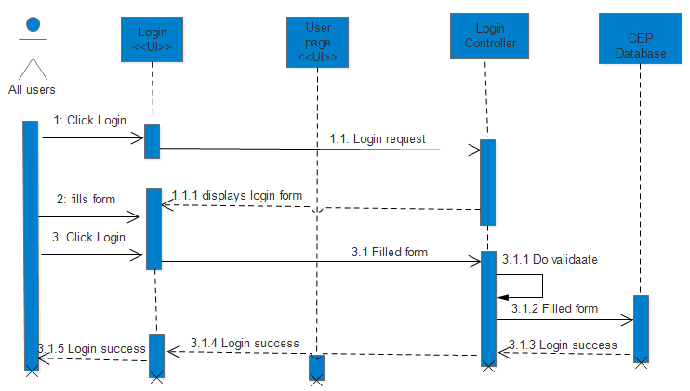

Figure 3 Sequence diagram of logout

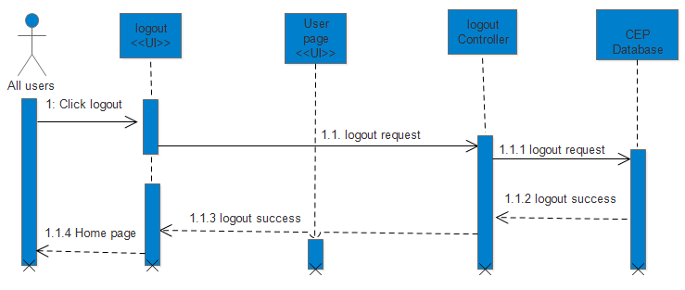

Figure 4 Sequence diagram of access student information i.e. search student

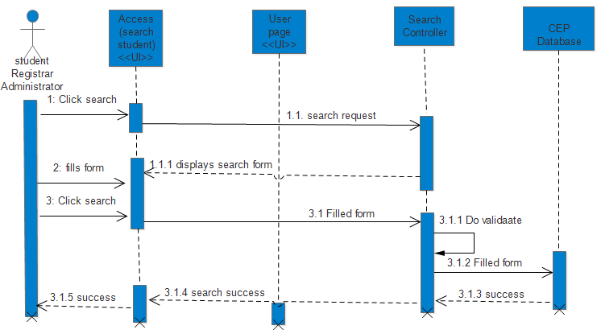

Figure 5 Sequence diagram of Apply registration request

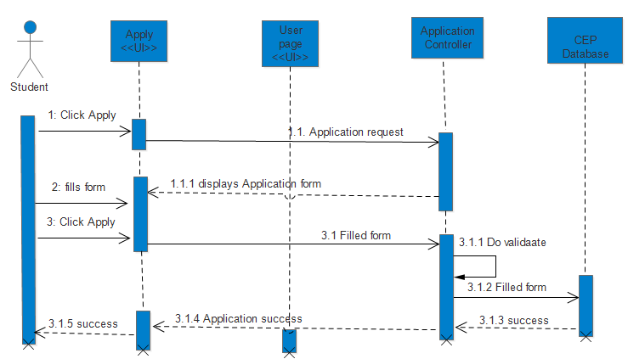

Figure 6 Sequence diagram of register online

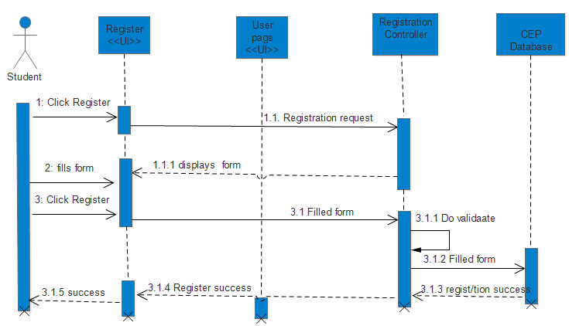

Figure 7 Sequence diagram of view grade report

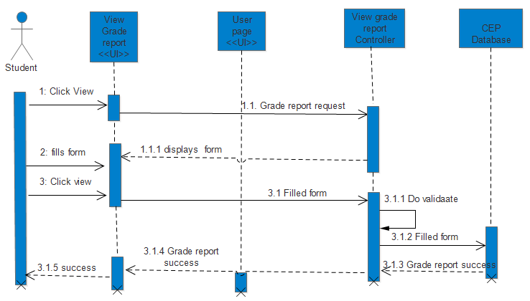

Figure 8 Sequence diagram of apply for registration request

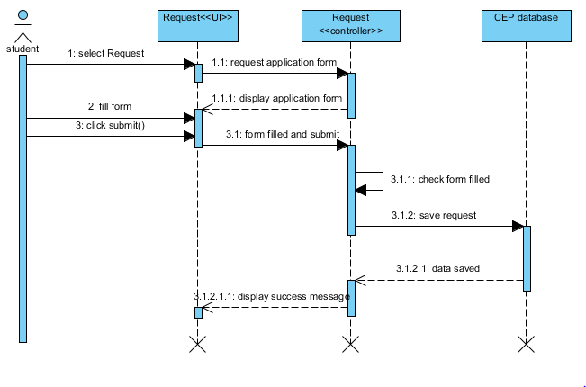

Figure 9 Sequence diagram of withdrawal request

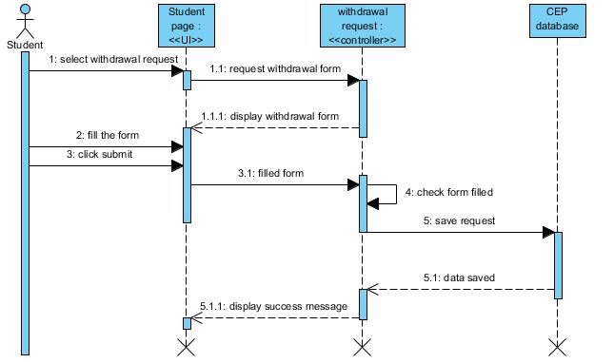

Figure 10 Sequence diagram of Accessing E-Learning

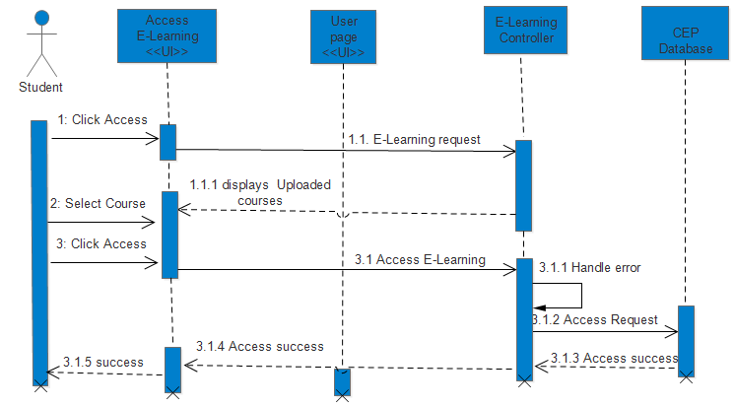

Figure 11 Sequence diagram of online payment i.e. Transaction

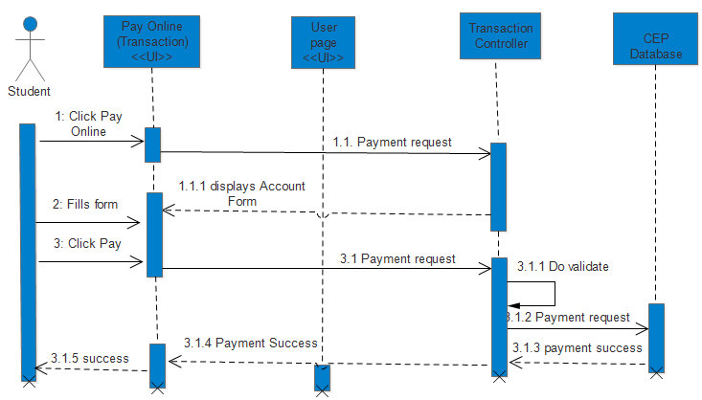

Figure 12 Sequence diagram of Handling request i.e. request approval

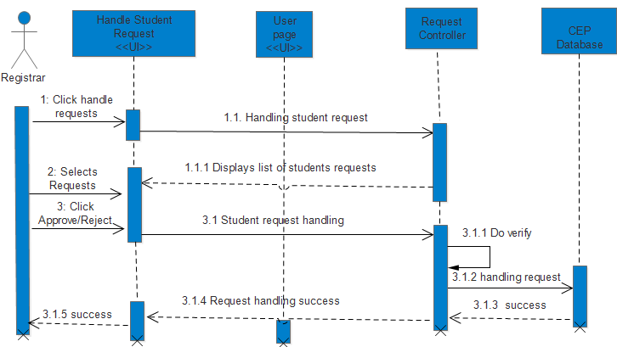

Figure 13 Sequence diagram of Upload e-learning resources for students i.e. E-Learning

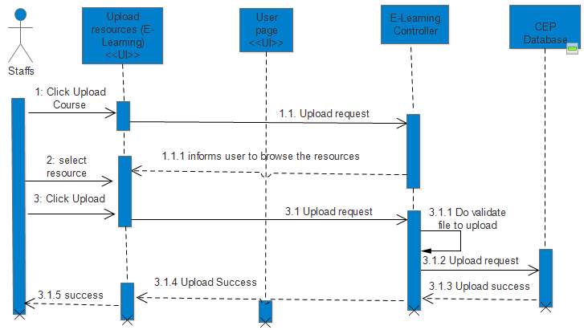

Figure 14 Sequence diagram of sending notification for students

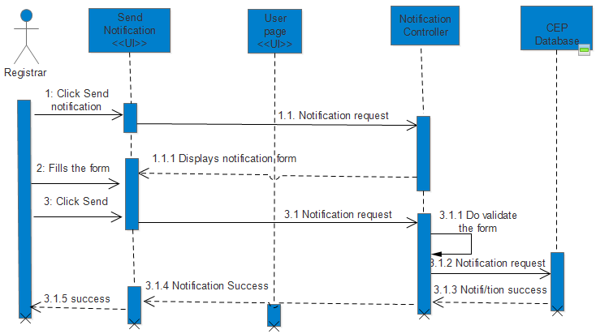

Figure 16 Sequence diagram of handling student payment and generating receipt paid students

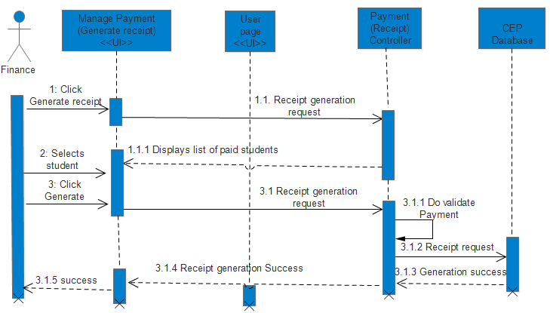

Figure 17 Sequence diagram of make ID card

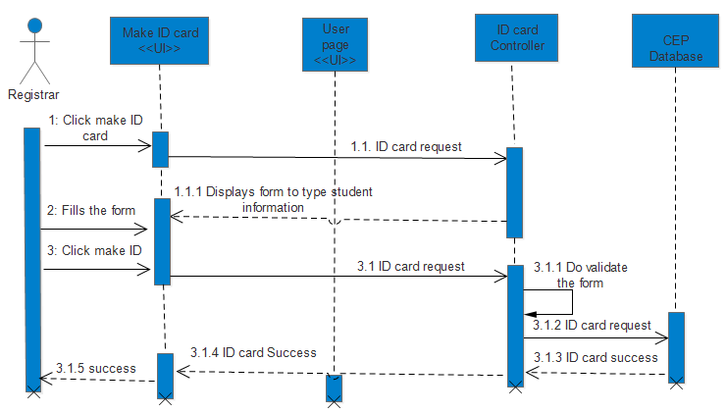

Figure 18 Sequence diagram of Generate grade report

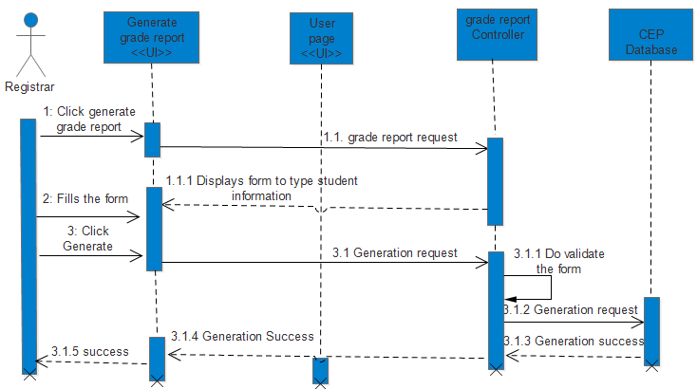

Figure 19 Sequence diagram of submitting student grade report

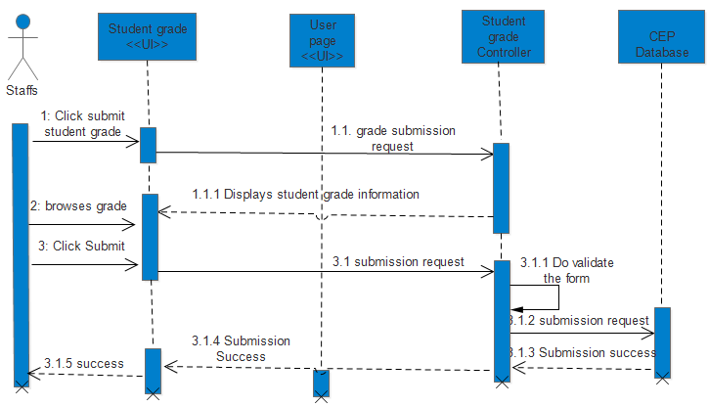

Figure 20 Sequence diagram of Manage user account

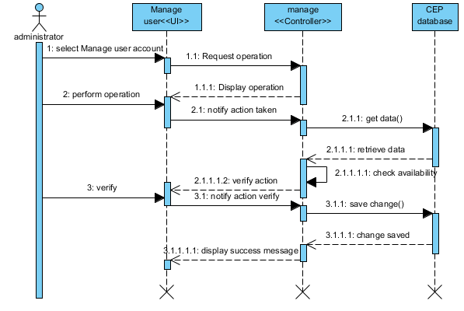

Figure 21 Sequence diagram of create user account

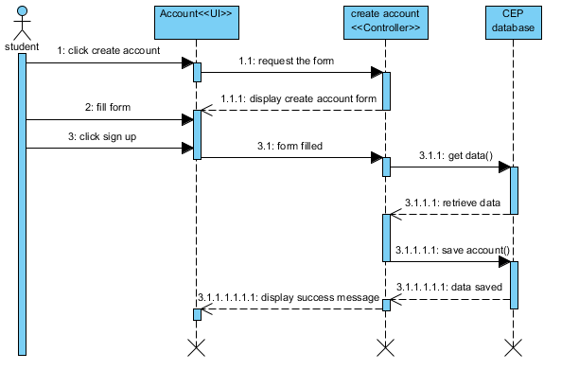

Figure 22 Sequence diagram of updating account

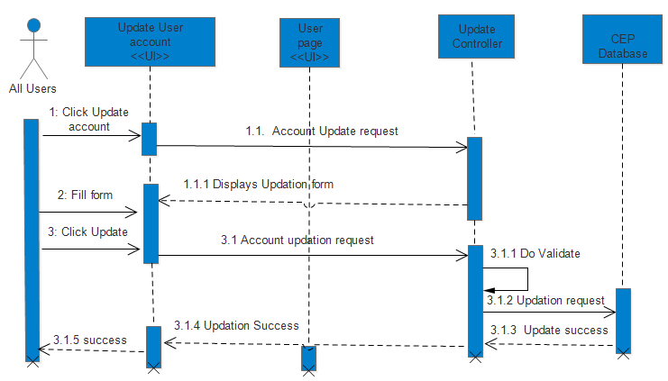

Figure 23 Sequence diagram of update/change user account

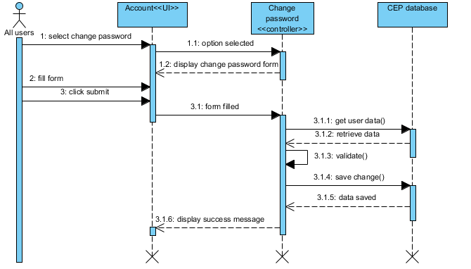

## 2.5 State chart diagram

Figure 24 State chart Diagram of student class

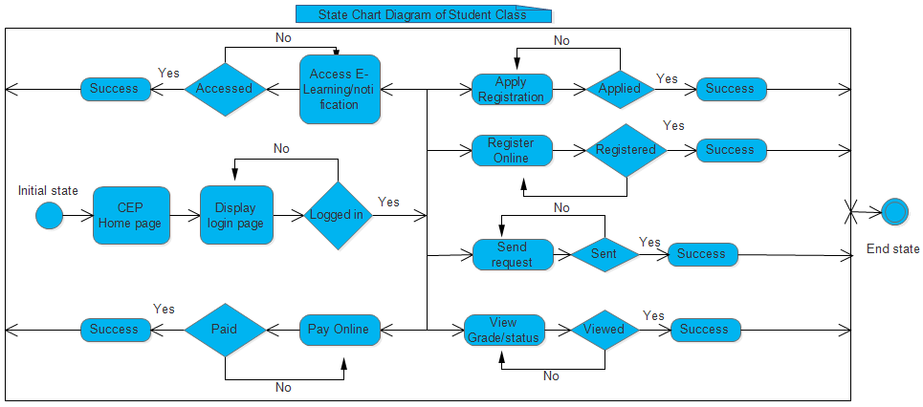

Figure 25 State chart diagram of Registrar class

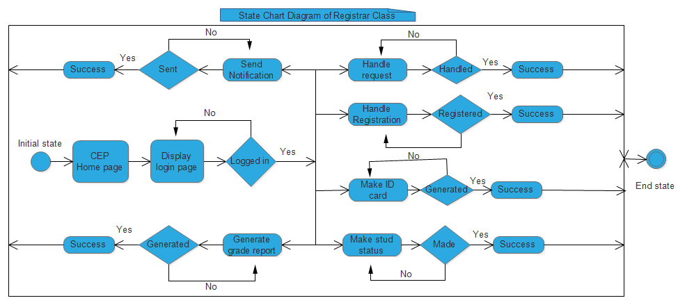

Figure 26 State chart diagram of Administrator class

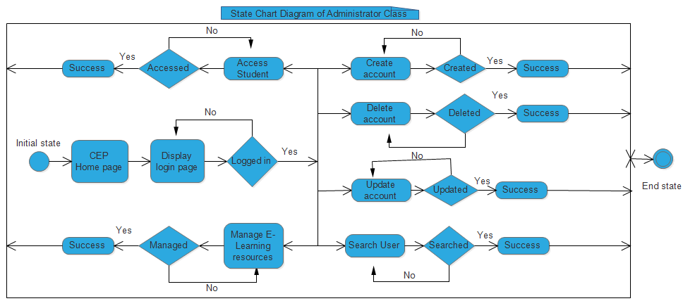

Figure 27 State chart diagram of Staff Class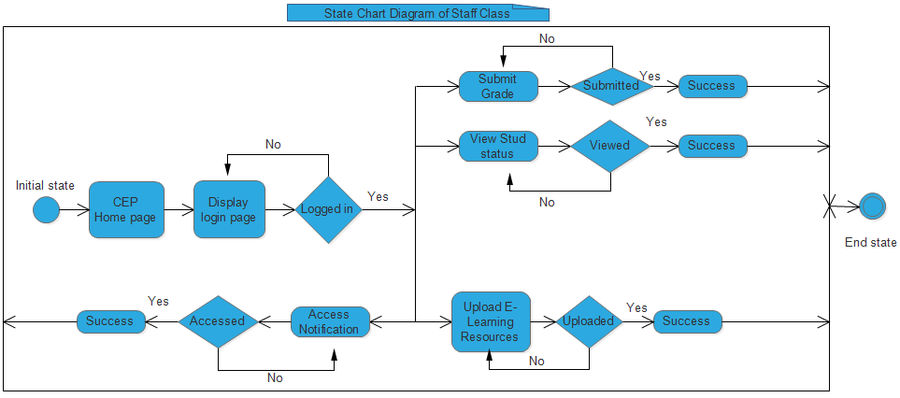

Figure 28 State chart diagram of Finance class

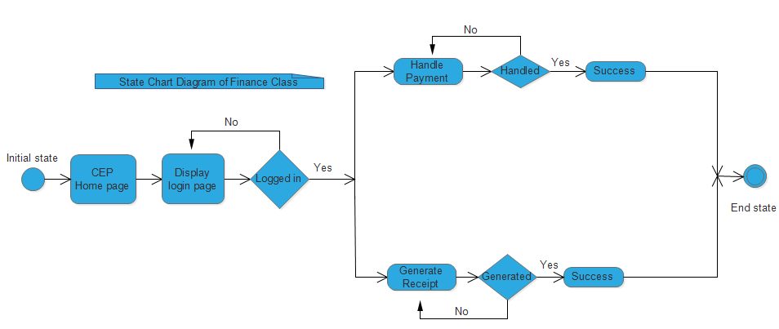

## 2.6 Activity diagram

Figure 29 Activity diagram of search or access student information

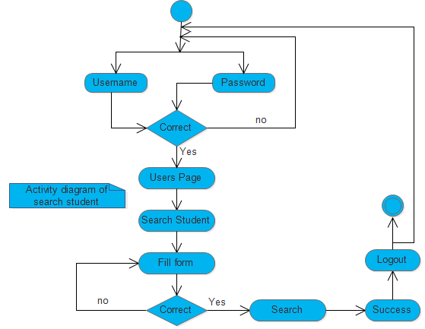

Figure 30 Activity Diagram of Register online

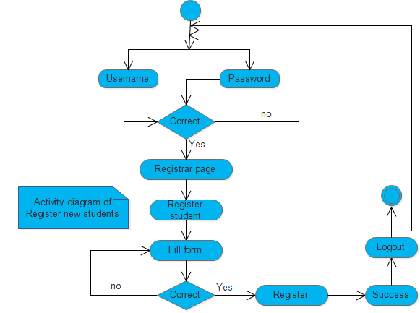

Figure 31 Activity diagram of handling student request

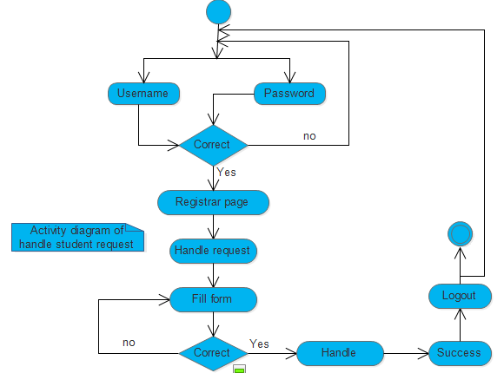

Figure 32 Activity diagram of make student status

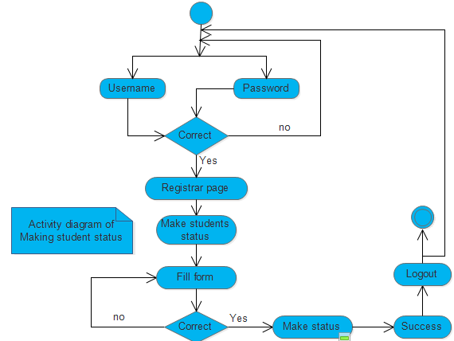

Figure 33 Activity diagram of make ID card for students

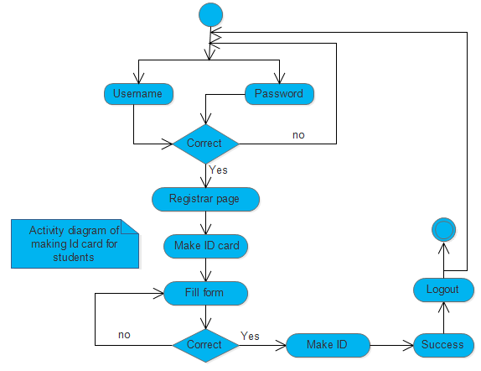

Figure 34 Activity diagram for upload e-learning resources for students

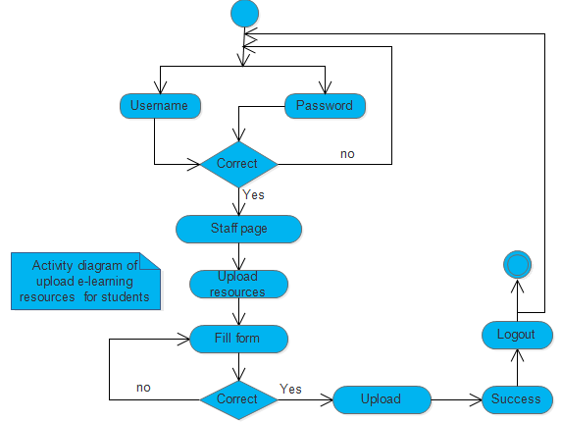

Figure 35 Activity diagram for send notifications for students

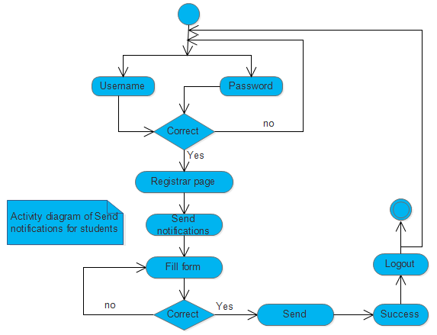

Figure 36 Activity diagram of register online or register new student

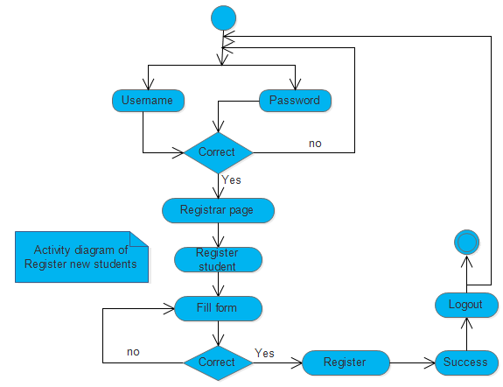

Figure 37 Activity diagram of generate grade report for students

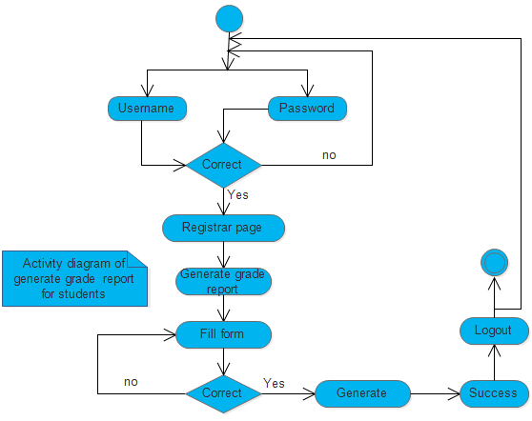

Figure 38 Figure 38 Activity diagram of generate receipt for students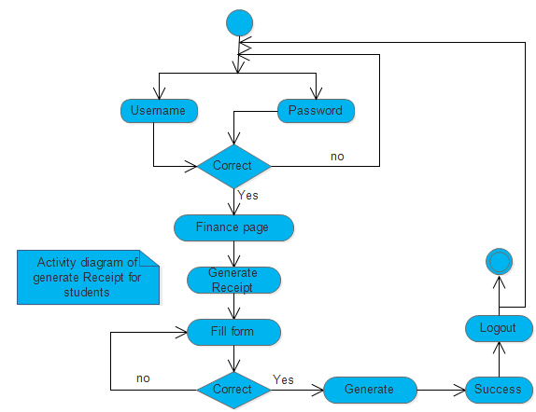

Figure 39 Activity diagram of manage account

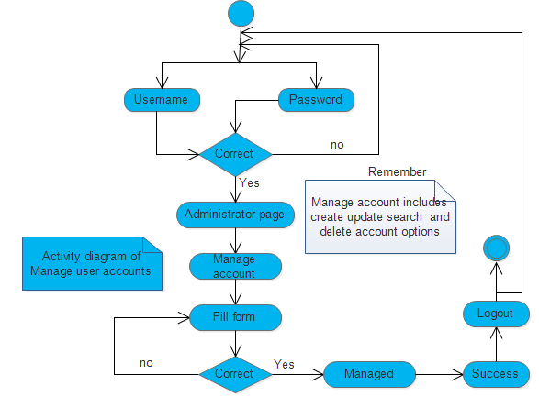

Figure 40 Activity diagram of Manage E-Learning

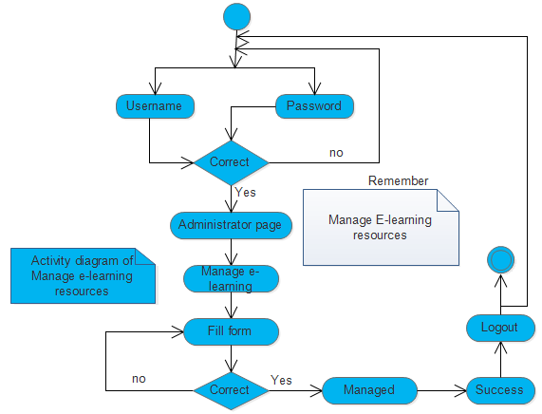

Figure 41 Activity diagram of pay online for the courses

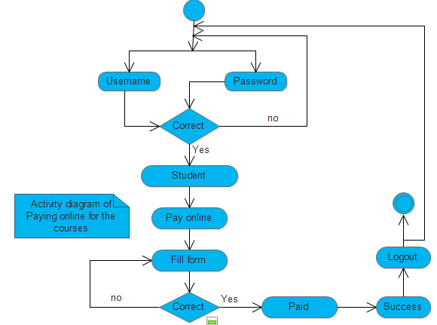

Figure 42 Activity diagram of access E-Learning Resources

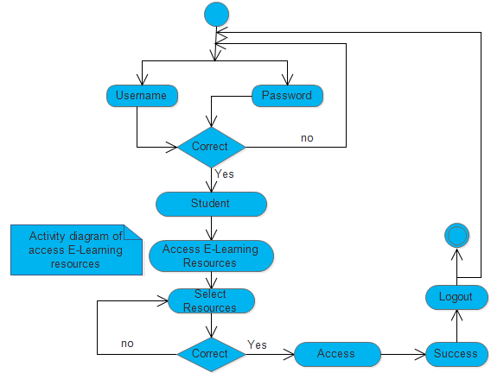

Figure 43 Activity diagram of viewing grade report and viewing status

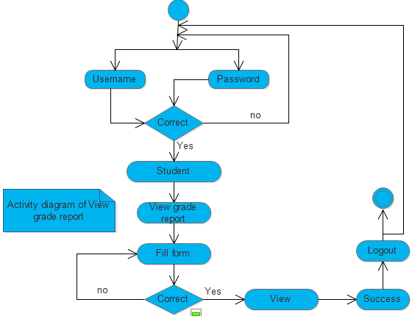

Figure 44 Activity diagram of upload e-learning resources

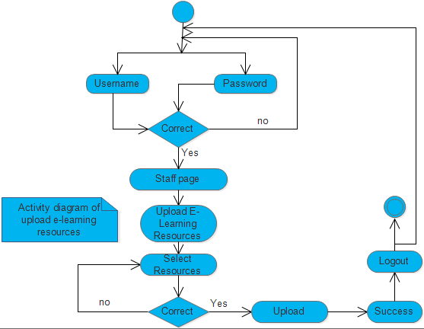

Figure 45 Activity diagram of Submit student grade report

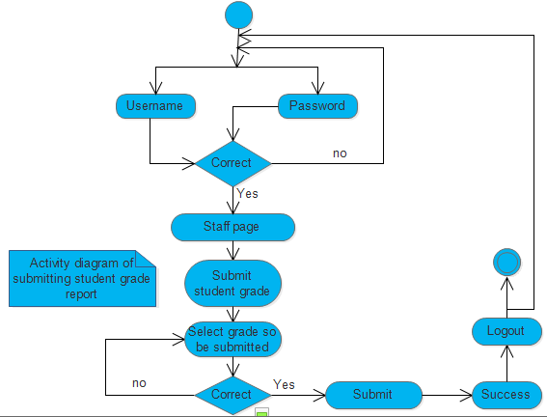

Figure 46 Activity diagram of send withdrawal request

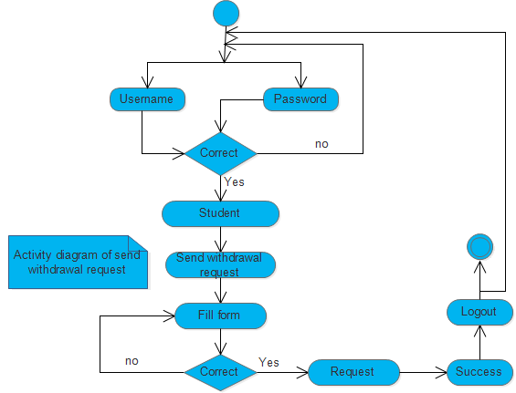

## 2.7 Key abstraction with CRC analysis

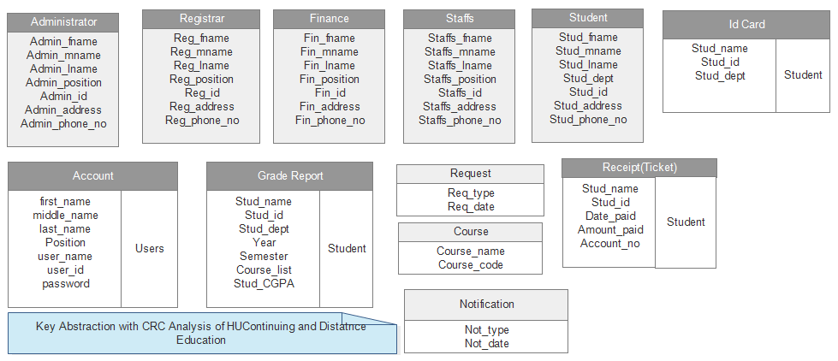

Figure 47 Key abstraction with CRC analysis.

## 2.8 Conceptual modeling: Class diagram



Figure 48 Class modeling diagram.

## 2.9 Identifying change cases

There are a lot of changes cases that can be added or modified in Haramaya University distance and continuing education (HUDCE) in the future time as much as possible when the technology improvement occurs. Some of this change cases are: -

* Including all student participations in school including different kinds of student clubs in the University. Students may participate in another social and political issues related to their education in the University so the distance and continuing education of Haramaya University can be modified to include these information.
* It can also modify to include and handle student’s criminal related occasions in their respective departments and the rules and regulations of the University.
* Another aspect of change case is the system can be modified to include online examination auto correction and sending students mark to their respective email accounts.

Generally these change cases can be modified in the distance and continuing education management system of Haramaya University for the future time in connection with technology improvements. Potentially these change cases can improve all the working conditions and functionality areas of the system for the students, teachers and the community of the University.

## 2.10 User Interface Prototyping

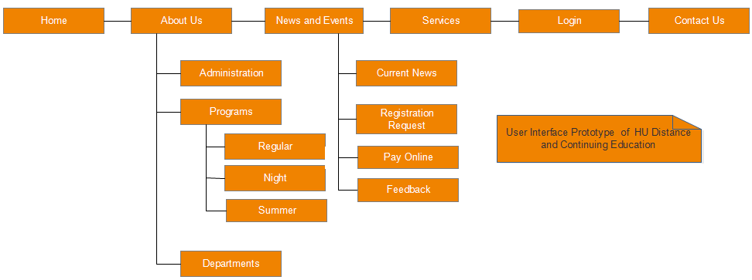

Figure 49 User Interface design or user interface prototype

# Chapter Three: Design

## 3.1 Purpose and goals of design

The design goals are derived from non-functional requirements that mean non-functional requirement is the description of the feature characteristics and attributes of the system as well as any constraints that may limit the boundary of the proposed solution.

During the Design Phase, the system is designed to satisfy the requirements identified in the previous phases.

The requirements identified in the Requirements Analysis Phase are transformed into a System Design phases, this is in turn transformed into implementation and testing phases.

In this system, the documentation accurately describes the design of the system and that can be used as an input to system development in the next phase.

### 3.1.1 Objectives of design goals

* Transformation of all requirements into detailed specifications covering all aspects of the system
* Assessment and planning for security risks
* Approval to progress to the Development Phase
* Opening the ways for implementation phases
* Simplifying and reducing complexity of implementation phases

**Goals**

The purpose and goal of the Design Phase is to transform the requirements into complete and detailed system design specifications.

The other most important design goal is making the system: -

* Reliable: the system should be reliable.
* Fault Tolerance: the system should be fault tolerant to loss of connectivity with the service.
* Security: the system should be secure, i.e., not allow other users or unauthorized users to access data that don’t concerns with them.
* Modification: the system should be modifiable for further modification and enhancement of the application.

### 3.1.2 Current software architecture

Actually, as we explained in the chapter one the distance and continuing education of the University, it performs all of its activities manually. All the operations are the paper based and the student information is kept up (placed) in the shelf one by one in the order of their departments and by batch i.e. the year that a certain student entered to the University.

So all of these information’s are in the paper document.

### 3.1.3 Proposed software architecture

The proposed software architectures of distance and continuing education of Haramaya University are as follows.

* **HTML: -** This is defined as hypertext markup language which is used for designing the user interface for this system.
* **JavaScript: -** This is also one of the programming languages which are used for validation purpose. In this system different types of forms are going to be validated in the programming part and design part in order to insert a valid data to the database. The validation can be in two ways namely client side and server side.
* **PHP: -** This programming language is used write the server side programs which can be database connectivity and different algorithms to solve particular problems which we are going to solve in the implementation part of this system.
* **Notepad++: -** We used this software to write all programs which we used for this system written in above listed programming languages.
* **Browsers:-** These include Mozilla Firefox, Google Chrome, Opera Mini, Internet Explorer, Netscape browser and some others browsers. These are used to run the system in the computer system. These operating systems can be installed in the client computers and therefore can be accessed as much as needed.
* **MySQL Database and XAMPP Server:** - This are used to store student information and all other operations that are taking place in registrar related to distance and continuing education and therefore can be accessed by only authorized users for the security cases. These operating systems should be installed only in the server or the computers that are acting as the server.
* **Microsoft word and Microsoft Excel: - These** are also the operating systems that are used in the proposed system during the times of generating grade report, tempo or student copy and receipt for students whom finish their academic year and for any cases as much as possible. This software’s are also installed in the client computers.

## 3.2 Hardware/Software mapping

### Software

Php is used to develop the website in the software side since it is more advanced and efficient for creating websites and also used by a lot of programmers in the whole over the world.

HTML and JavaScript programming languages that are used to develop user interfaces and other user interface related forms that are needed in the distance and continuing education management system of Haramaya University.

SQL server 2008: this is the database software that we will be used to store all the information required to keep the web site running. Everything from the user details to product information and a host of other things will be stored in the MySQL database.

**Software at server side**:

1. MySQL server 2008
2. Linux
3. Windows server 2008

**Software at clients’ side:**

1. Micro soft-Internet Explorer
2. Mozilla Firefox
3. Google Chrome
4. Opera

### Hardware

The system will use the following hardware:

1. 2GB Min. RAM
2. Intel® Core™2 Duo CPU
3. 360 GB Min. HDD

## 3.3 Subsystem decomposition

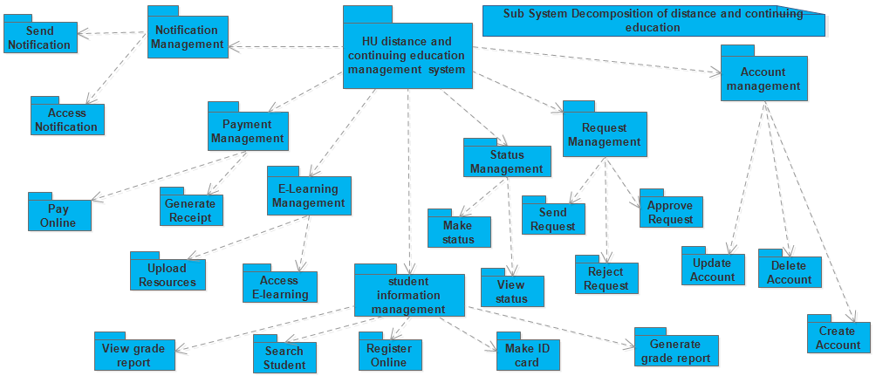

Figure 50 Sub system decomposition

## 3.4 Class Collaboration Diagram

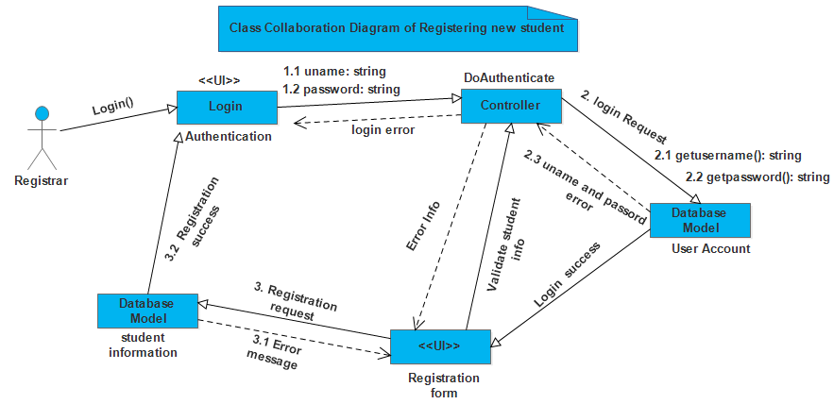

Figure 51Class Collaboration diagram of registering new student.

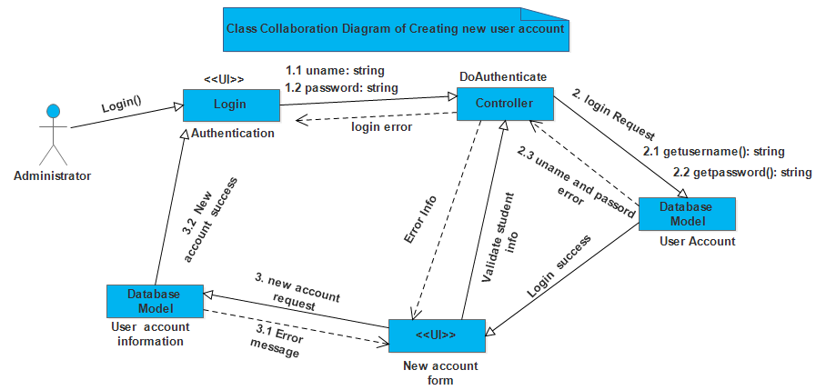

Figure 52 Class Collaboration diagram of creating new user account.

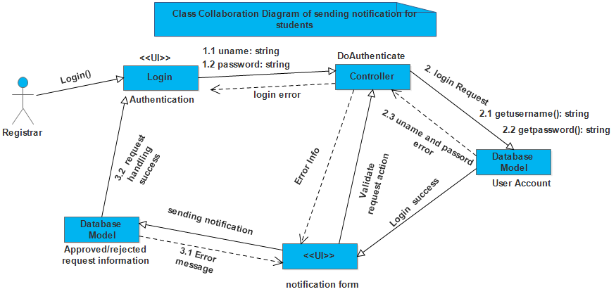

Figure 53 Class Collaboration diagram of handling student’s request.



Figure 54 Class collaboration diagram of sending notification for students

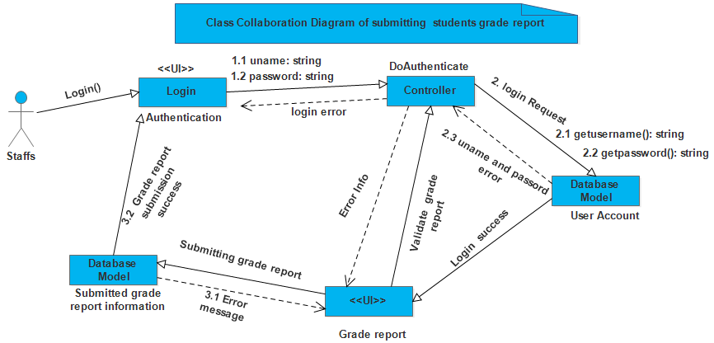

Figure 55 Class collaboration diagram of submitting students’ grade report

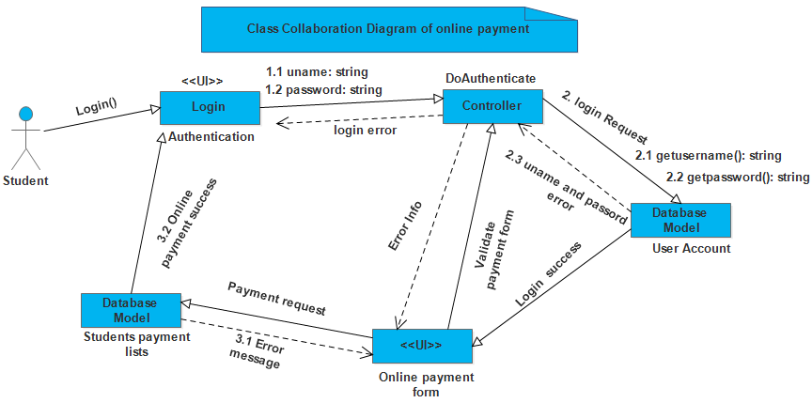

Figure 56 Class collaboration diagram of online payment

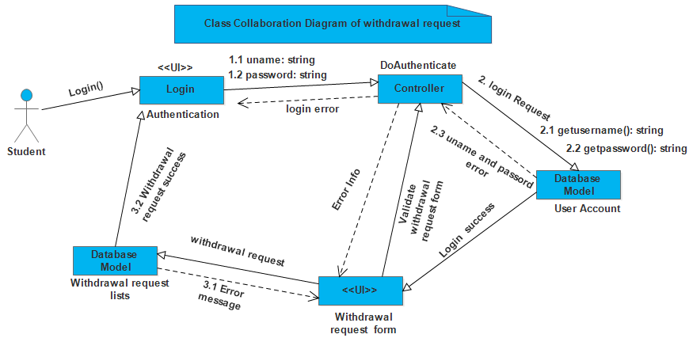

Figure 57 Class collaboration diagram of sending withdrawal request

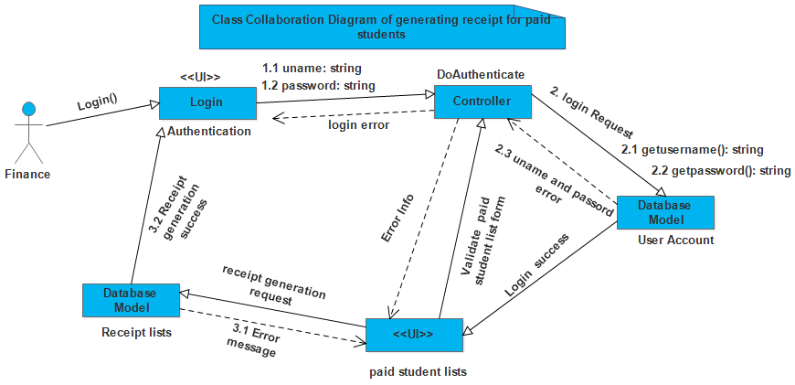

Figure 58 Class collaboration diagram of generating receipt for students

## 3.5 Layering class model

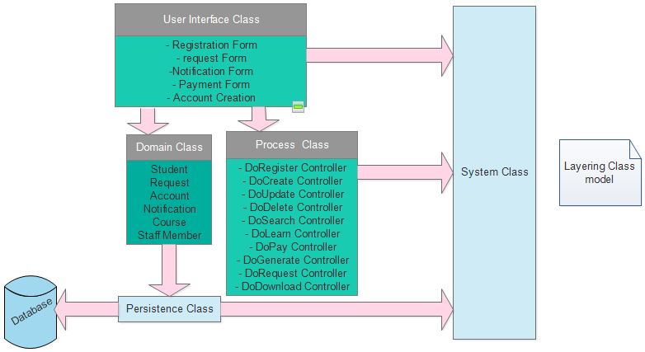

Figure 59 Layering class model

## 3.6 Component diagram

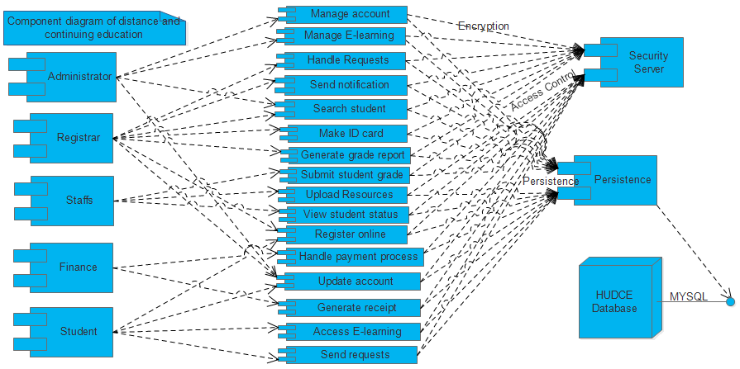

Figure 60 Component diagram

## 3.7 Deployment diagram

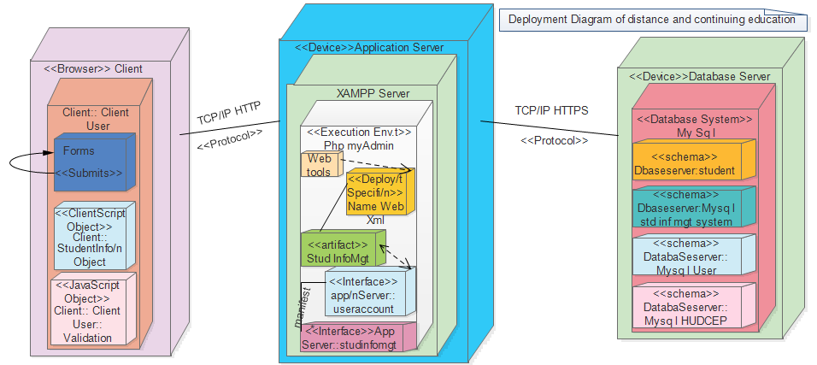

Figure 61 Deployment diagram of distance and continuing education

## 3.8 Persistence modeling for object oriented database

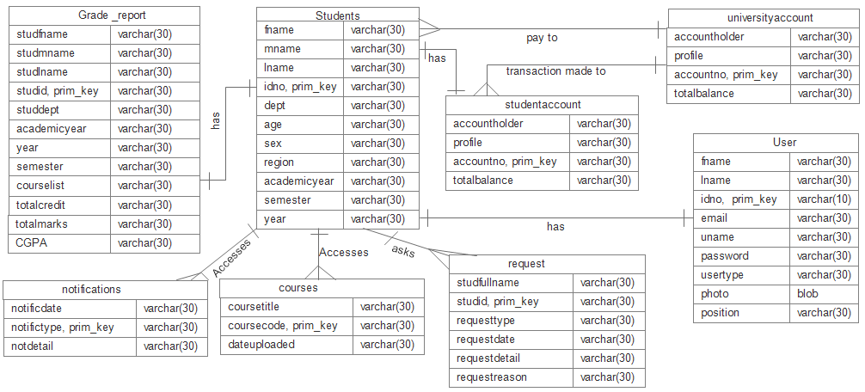

Figure 62 persistence modeling diagram

## 3.9 Access control and security

The access control systems in distance and continuing education of Haramaya University are:

* Physical or electronic systems which are designed to control who has access to a network. One of a physical access [control system](http://www.wisegeek.com/what-is-a-control-system.htm) is a door which can be locked; this is for limiting people to one side of the door or the other.
* Electronic versions typically control [network security](http://www.wisegeek.com/what-is-network-security.htm), limiting which users are allowed to use resources on a computer system, for example.

**The granted access privileges for the actors of the distance and continuing education of the University are: -**

* The **Administrator** has an authority to access the whole module of the system
* The **Registrar** has an administrative privilege to modify his own user account and approve the requests of the student access right to see students’ personal information.
* The **Staffs** have an administrative privilege to submit student grade report and upload e-learning resources for students in addition to updating their own user accounts.
* The **Finance** has an administrative privilege to see students who are paid their education payment and access to modify his account information.
* **Students’** have an access privilege to see their personal information and apply different kinds of request.
* They do not have the administrative privilege to modify their personal information except his/her user account.

**Security Procedures and principles of the system**

There are the defined security mechanisms for the system which are defined by the system administrators of the system since securing the student information in registrar is the most common issue. These security principles are: -

* Unauthorized user can’t log into the system being in or outside anywhere from the University compound i.e. including different branches of the University.
* Unauthorized user cannot access student information by using any computer within the University compound.

These security procedures are maintained in the University by configuring the firewall and configuring the access control lists in the router to deny and permit only required services in their network.